

**The A to Z**

**Parent/Carer Handbook**

“We know what we are, but know not what we may be.”

**William Shakespeare**

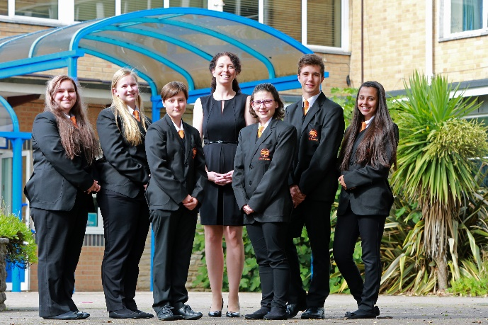



**High Expectations lead to High Achievers**

**CONTENTS**

|  |  |
| --- | --- |
| Contents | Page Number |
| Welcome from the Principal | 6 |
| The Academy Day | 7 |
| List of Key Staff | 8 |
|  | |
| The A – Z of Oak Academy | |
| Attendance |  |
| Behaviour | 9 |
| Breakfast Club | 9 |
| Careers | 9 |
| Digital Wellbeing | 10 |
| Enrichment | 11 |
| Essential Equipment | 11 |
| Governing Body | 12 |
| Hegarty Maths | 12 |
| Homework | 12 |
| House System | 12 |
| Junior Leadership Team | 12 |
| Learning for Life | 12 |
| Lost Property | 13 |
| Lunchtime | 13 |
| Medication | 14 |
| Mentoring | 14 |
| Mobile Phones | 14 |
| Parent Consultation Evenings | 14 |
| Personal Property | 14 |
| Personal Records | 14 |
| Personal Tutor Time Programme | 15 |
| Punctuality | 15 |
| Pupil Premium | 15 |
| Rewards | 16 |
| Safeguarding | 16 |
| Special Educational Needs & Disabilities | 17 |
| Student Planner | 18 |
| Uniform | 18 |
| Welfare | 19 |



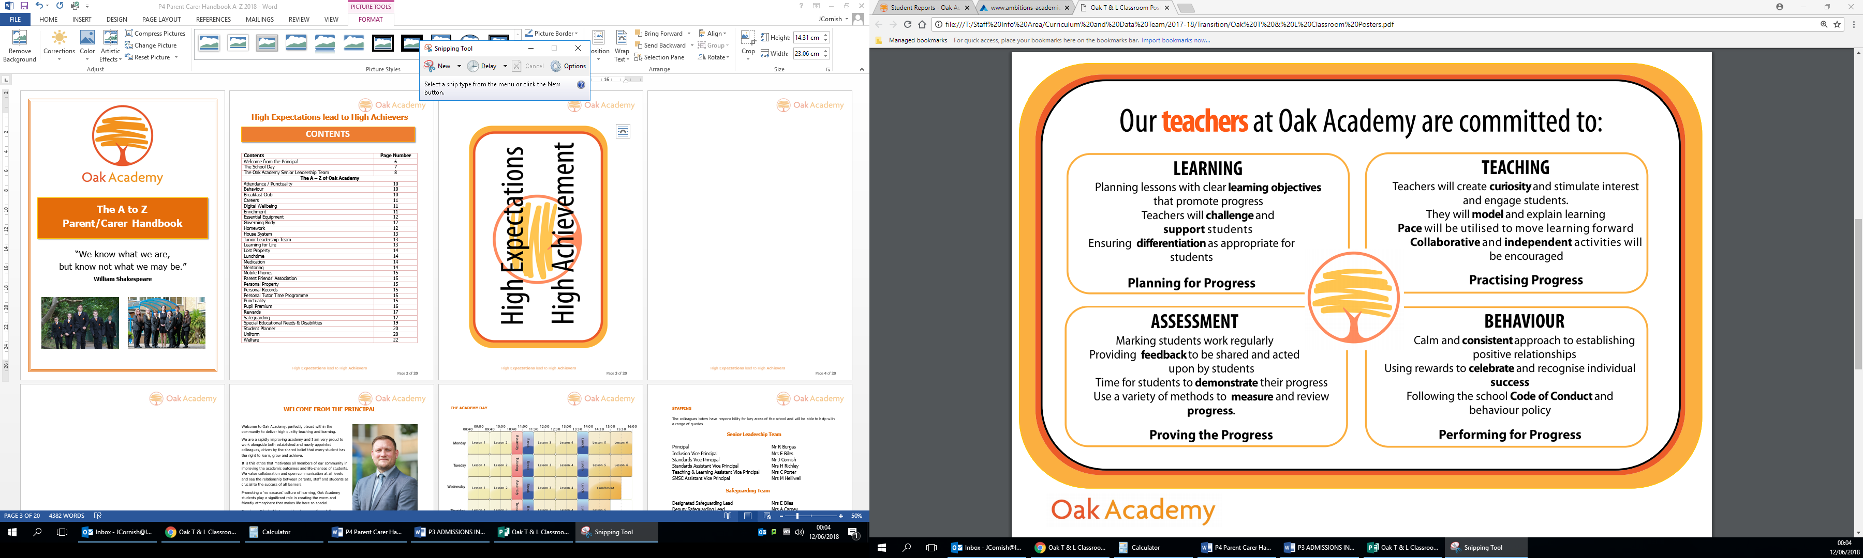

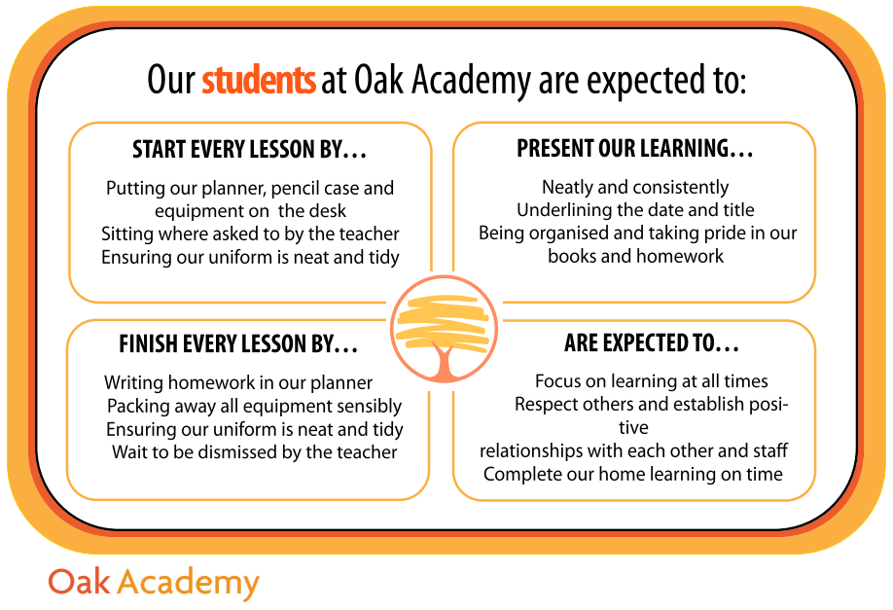

**WELCOME FROM THE PRINCIPAL**

****Welcome to Oak Academy, perfectly placed within the community to deliver high quality teaching and learning.

We are a rapidly improving academy and I am very proud to work alongside both established and newly appointed colleagues, driven by the shared belief that every student has the right to learn, grow and achieve.

It is this ethos that motivates all members of our community in improving the academic outcomes and life-chances of students. We value collaboration and open communication at all levels and see the relationship between parents, staff and students as crucial to the success of all learners.

Promoting a ‘no excuses’ culture of learning, Oak Academy students play a significant role in creating the warm and friendly atmosphere that makes life here so special.

My aim as Principal is to provide a happy, safe and diverse environment; one that challenges all of us to develop as learners so that we feel confident in meeting whatever life holds for the future.

This handbook is an alphabetised explanation of the structures and opportunities we have in order to uphold our **High Expectations**.

Although not a definitive list, it is a useful go-to guide in understanding ‘all things Oak.’

Do not hesitate in contacting me should you have any questions regarding how we can support your child in being “the best they can be.”



Richard Burgas

Principal

Oak Academy

[rburgas@leaf.bournemouth.sch.uk](mailto:rburgas@leaf.bournemouth.sch.uk)

01202 774600

**THE ACADEMY DAY**

The times of the day for the 2020-21 academic year are shown below:

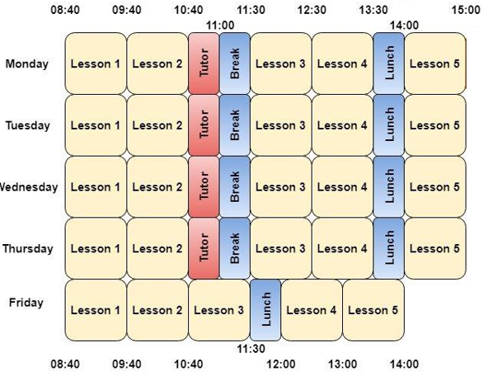

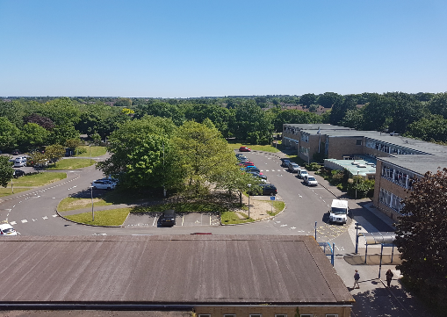****

**STAFFING**

The colleagues below have responsibility for key areas of the school and will be able to help with a range of queries

**Senior Leadership Team**

Principal Mr R Burgas

Vice Principal - Inclusion Mrs E Biles

Vice Principal - Standards Mrs H Richley

Vice Principal - SMSC, Careers and AP Mrs M Helliwell

Assistant Vice Principal - KS3 Standards Ms K Price

**Safeguarding Team**

Designated Safeguarding Lead Mrs E Biles

Deputy Safeguarding Lead Mrs J Phillips

Extended Safeguarding Teams Mrs M Helliwell

Mrs B Howard

Mrs S Buxton

Miss K Trott

Miss N Grew

Mrs K Stephenson

**Other Key Contacts**

Special Education Needs & Disabilities Co-ordinator Mrs S Buxton

Family Liaison Officers Miss K Trott

Miss N Grew Exams and Admissions Officer Mrs A Foster

Data Manager Mrs P Bartlett

Careers Advisor Mrs K Speed

**Curriculum Area Leaders**

English Miss L Brunt

Maths Ms K Price

Science Mr J Wacker

Humanities Mr G Whitworth

Modern Foreign Languages Miss K Trott

Creative Arts Mrs A Whitby

Performing Arts Mrs A Joy

PE Mr M Pretty

**ATTENDANCE**

The Government has set 96% as its minimum expectation for attendance. You will be aware that there is significant evidence to show that students with attendance below 96% are at much higher risk of not making expected progress. Positive attendance benefits academic and personal development and is a core expectation here at Oak. We ask for all students to aim for 100% attendance.

ATTEND TODAY

ACHIEVE TOMORROW

If your child is unwell, please inform the Academy Office on 01202 242300 by 8.30am. If we do not receive a message, parents/carers will be contacted on the first day of absence.

Should a student be absent from the Academy they will be expected to catch up work missed. We will offer opportunities to do this at the Academy, where possible, during lunchtimes or after school.

**BEHAVIOUR**

We strive to maintain a disciplined, organised and friendly atmosphere in which everyone treats each other with courtesy, tolerance and respect. Our aims are:

* to create an environment that allows teachers to teach and all learners to learn effectively.
* to encourage learners to develop high standards and good habits that will allow them to achieve their aspirations in their adult lives.

Mistakes are a fundamental part of learning. Warnings and an opportunity to correct poor behaviour are the immediate steps in helping learners make better choices.

**BREAKFAST CLUB**

A Breakfast Club runs daily from 7.30am in the canteen where a free breakfast is provided for all of our students. At break and lunch, students are able to purchase a range of hot and cold food and drinks.

**CAREERS**

Oak Academy are committed to delivering a Careers Education, Information, Advice and Guidance (CEIAG) programme which will help all students to develop the skills and knowledge they need to make the right choices for their future. By instilling our career guidance principle of ‘Ambition-drives-Outcome’, we broaden students’ horizons by increasing knowledge and understanding of career and educational opportunities and so build the confidence to achieve goals that may previously have been thought to be unobtainable.

Our Careers Strategy is based on the eight Gatsby Benchmarks for high quality CEIAG:

At Oak Academy, all staff have a responsibility to deliver careers advice and guidance no matter their subject area, role or responsibility. The key staff to contact directly regarding our careers programme are as follows:

**Strategic Careers leader – Mrs M Helliwell**

Responsible for driving forward the whole school careers strategy, Mrs Helliwell ensures the Academy delivers a wide range of nationally recognised programmes to engage students in a high quality approach that draws on local and national providers and partners. She can be contacted at [mhelliwell@leaf.bournemouth.sch.uk](mailto:mhelliwell@leaf.bournemouth.sch.uk)

**Senior Careers Adviser – Mrs Katherine Speed**

A professionally qualified Careers Adviser, Mrs Speed has extensive experience of providing careers guidance to 13 – 19 year olds with a wide range of aspirations and plans.

Mrs Speed offers individual careers interviews to students, concentrating on Years 10 – 13. The interview will be tailored to the individual student who will receive a detailed Careers Action Plan outlining the discussion and next steps. She can be contacted at [kspeed@leaf.bournemouth.sch.uk](mailto:kspeed@leaf.bournemouth.sch.uk)

**Work Experience Co-ordinator – Mr C Beeton**

Responsible for collaborating with our employer and business community in order to ensure our students have a minimum of 1 weeks’ worth of Work Experience and continue to have ‘meaningful workplace encounters’ throughout the year within every Year Group She can be contacted at [cbeeton@leaf.bournemouth.sch.uk](mailto:cbeeton@leaf.bournemouth.sch.uk)

**Careers & Enterprise Adviser – Mrs Helen Rivero**

As an MSc and Chartered member of the CIPD, Mrs Rivero brings a wealth of diverse business, HR, learning and development experience; including working within manufacturing, aerospace, education, construction, FMCG and the service sector. Mrs Rivero's aim is to infuse people with passion around learning and developing from a professional and personal perspective and she also runs the Young People’s Index: <https://www.youngpeopleindex.com/>

The careers team receive regular training and updates and is active in local initiatives and networks including the Careers & Enterprise Company (CEC), Southern Universities Network (SUN), National Careers Service (NCS) and Bournemouth Borough’s 14 – 19 CEIAG Network.

**COMMUNICATION**

We communicate regularly with our parents via text and email. We are therefore grateful for you keeping us informed of any changes to phone numbers and email addresses.

**DIGITAL WELLBEING**

Digital wellbeing at Oak is of paramount importance. We use technology and the internet extensively across all areas of the curriculum. Online safeguarding, known as E-Safety, Digital Citizenship and Digital Footprints are areas that are constantly evolving and as such we tailor our curriculum to meet these changes.

The Academy, in conjunction with the Junior Leadership Team, is currently undertaking the 360Degree Safe Award, allowing us to gain accreditation for the excellent work carried out around the Academy for our Digital Wellbeing curriculum.

**ENRICHMENT**

Year 7-9 will follow an Enrichment programme for two hours each fortnight and is an opportunity for staff and students to come together outside of the formal classroom environment as part of our personal development curriculum. A range of activities, based on student demand and led by staff, will be offered.

Other clubs, including Handwriting Club, Homework Club and various other sporting clubs take place after academy hours.

**ESSENTIAL EQUIPMENT**

Student books are a record of learning and a valuable resource in preparing for exams. As such, an Oak Academy branded bag must be used to ensure their safe movement between home and the Academy. An A4 sized bag and/or handbags are not appropriate.

All exercise books, paper and text books will be provided by the academy for your child. Students will, however, be expected to provide other items of stationery, including pens and pencils, for themselves.



As a minimum requirement students will need:-

• 2 black pens

• Pencil

• Ruler

• Rubber

• Pencil sharpener

In addition it would be extremely useful for them to have:-

• Coloured crayons/felt tips

• Glue stick

• Pocket dictionary

• Protractor

• Set square

• Scientific calculator

• A compass

It is advisable that ALL equipment, including items of uniform and PE Kit, are clearly marked with your child’s name.

**GOVERNING BODY**

Oak Academy is part of Ambitions Academies Trust (AAT). AAT comprises schools from all sectors: mainstream (primary and secondary) and special. AAT secures outstanding achievement and improved life chances of all its pupils. All our Academies have high expectations as the focus of their work. They are strongly committed to supporting colleagues in developing their careers further and offer excellent CPD opportunities. More information can be found here: <http://www.ambitions-academies.co.uk/>

**HEGARTY MATHS**

Hegarty Maths is an online website created by UK Teacher of the Year and Global Teacher Prize Top 10 Finalist, Colin Hegarty. We use Hegarty Maths to provide a top quality home learning platform so that, along with fantastic teacher-led maths lessons in our school, your child will be supported at home with their maths learning. This system makes it easier for your child to engage with their maths homework. It teaches, assesses and tracks everything your child needs to learn in school maths. Your child will be given a homework book to take notes and complete the homework in. Homework will be set weekly and monitored by your child’s teacher weekly in lessons.

**HOMEWORK**

Students in Year 7 and 8 will be given knowledge organisers at the start of each half term. These will form the large basis of their homework. A timetable is given alongside this which makes it easy to follow.

In Maths all students will also be set homework through Hegarty Maths (please see above).

We believe homework is important for future success. Homework that is not completed may result in detentions being set.

**HOUSE SYSTEM**



All students are proud and active members of our newly formed House

System. Students are assigned to one of four Houses; Pegasus (Green),

Griffin (Purple), Phoenix (Orange) and Caladrius (Blue) and will stay

in their House all the way through the Academy.

Siblings are assigned to the same House groups.

**LEARNING FOR LIFE**

At Oak Academy we recognise that the personal development of students; spiritually, morally, socially and culturally plays a significant part in their ability to learn and achieve. The Academy strives to build a community which encourages all its members to develop a healthy respect for each other.  In addition, we provide a happy, stimulating and caring environment where there are opportunities, encouragement and stimuli to develop each student to their full potential.

Our programme includes an extensive range of age appropriate subjects which are covered in depth each term. We are compliant with the Governments new Relationships and Sex Education proposals and engage in communication with parents regarding our programme of study.

**The Learning for Life Programme:**

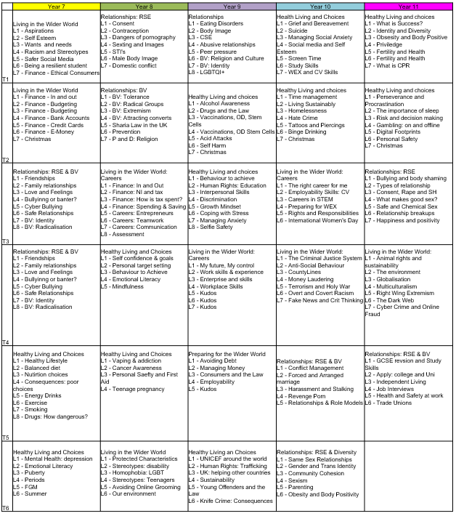

The curriculum includes collaboration and links with local and national employers, universities and colleges, health care providers, public service providers, ICT & Media platforms, to name but a few.

We are committed to ensuring that every student continues their journey beyond Oak Academy, with both the grades and life skills needed to access every opportunity available.

**LUNCHTIME**

The canteen is open every break and lunchtime. A range of hot and cold snacks and drinks are readily available and vegetarian options are always provided. The cost of a meal is £2.45 and drinks cost between 40p and £1.00 and water is always available. We do ask that re-useable bottles are provided so we can minimise the amount of single use plastic. Students may bring a packed lunch and eat this in the canteen or playground.

We use a cashless payment system using your child’s fingerprint, swipe card or pin number so that students do not have to carry cash to school every day. Students who are entitled to a free school meal will still receive this.

‘Year 7 has been brilliant, you go on good trips’ - AS

We do not allow students to go off site during lunchtime.

**LOST PROPERTY**

Please make sure that your child’s name is on everything they bring to school.

If they are unable to find a lost item after a thorough search, they should ask at main reception at break, lunchtime or after school.

**MEDICATION**

Students who need inhalers are responsible for their administration and should carry them for easy access. Students may also be prescribed medication from time to time, this can be stored in the Inclusion Support Centre. Medication should be taken at convenient breaks as far as possible. Staff are not authorised to give any non-prescribed medicines to students.

**MENTORING**

Mentoring, at its core, guarantees young people that there is someone who cares about them, assures them they are not alone in dealing with day-to-day challenges or their academic progress, and makes them feel like they matter. Research confirms that quality mentoring relationships have powerful positive effects on young people in a variety of personal and academic situations. Ultimately, mentoring connects a young person to personal growth and development, and social and economic opportunity. Here at Oak Academy young people meet regularly with their tutor to speak with them regarding their social and academic development.

**MOBILE PHONES**

The Academy will not take responsibility for mobile phones which are lost or damaged on site. Any mobile phone brought on the premises must be switched off and kept out of sight during lessons. Mobile phones can only be used on the playground or canteen, or in lessons if directed by staff as part of learning. Mobile phones will be confiscated until the end of the day if these expectations are not met.

**PARENTS CONSULTATION EVENINGS**

Parents evenings are held throughout the Academic year and can be booked using our online system at <https://oakacademyaat.parentseveningsystem.co.uk/>. Dates will be released at the start of the Academic year.

**PERSONAL PROPERTY**

Students should not bring large sums of money, expensive clothing or valuables of any kind on site. The Academy cannot accept responsibility for lost, missing, or stolen property of any kind. It is important that clothing, school bags, instruments, and other property should never be left unattended.

**PERSONAL RECORDS**

Year 7 was a great year, there were lots of new things and amazing teachers. - RC

In order to maintain accurate records, please notify the

Academy immediately in writing when changing address, telephone

or email details. This will ensure that the Academy can contact you

quickly in an emergency.

**PERSONAL TUTOR TIME PROGRAMME**

At Oak Academy we run a structured Tutor Time Programme, including a weekly assembly. Our online platform; LINOIT, allows our community to engage with the wider world, discuss the Thought for the Week and chart their rewards and attendance. Once a week, students have an allocated ICT slot, where numeracy and careers tasks are undertaken. Tutor sessions create a positive ethos and develop both a Tutor, House and Academy identity.

**PROGRESS**

At Oak Academy, we believe in working closely with parents and carers in order to help you understand the progress that your son or daughter is making.

Parents and students are given reports every twelve weeks and every six weeks in Year 11. These include target and current attainment grades or pathways and information about attitude to learning and homework.

More information can be found on our website: <https://www.oak-academy.co.uk/parents/student-reports/>

**PUNCTUALITY**

Parent/carers are responsible for ensuring that students arrive at the Academy by 8:25am promptly, ready for Period 1. Students who arrive after 8:40am will receive a break time detention on the same day, unless they have a note providing a valid reason for their lateness.

**PUPIL PREMIUM**

You may be aware that the government is currently allocating additional funding to schools in the form of The Pupil Premium Grant. There are various circumstances which can attract Pupil Premium funding:

* Children eligible for Free School Meals (FSM)
* Children who have claimed FSM in the past 6 years
* Children of current Regular Armed Services Personnel
* Children designated as ‘Looked After’

(Looked After Children are children in the care of the Council, through a Care Order made by a court or voluntary agreement with their parent(s) to accommodate them. They may be looked after in a children’s home, by foster carers, or other family members. All unaccompanied asylum seeking children are also Looked After Children.)

The rationale behind the Pupil Premium funding is that historically, these groups of children have under-performed throughout their school careers across the country.

That is not to say that any individual will inevitably under-perform but the statistics, e.g. for those achieving the new Grade 5 Strong Pass measure or accessing higher education, are quite stark. The government has therefore decided to target money directly through schools to address this. Schools and Academies have the opportunity to use the money in whatever way they think is most appropriate for their students.

Pupil Premium funding is automatically awarded to the Academy based on the information we have on each student, so it is essential that we are made aware of any student eligible. Please make us aware if your child falls into any of these categories. In order to claim FSM a parent/carer must be claiming one of the following benefits:

* Income Support (IS)
* Income-Related Employment and Support Allowance
* Income-Based Job Seekers Allowance (IBJSA)
* Child Tax Credit except if you meet ANY of the following criteria:

1. Entitled to working tax credit (regardless of income)
2. Have an annual income in excess of £16,190 (please note this figure is for April 2013 and that it changes in April each year)

* The Guarantee Element of the State Pension Credit.
* Financially supported by the National Asylum Support Service (NASS)

The Pupil Premium money is directly allocated to the Academy and used to fund a range of initiatives to ensure all of these students are given the same access to opportunities as the rest of their peers, including trips, tutoring and other academic and personal support. All of this is decided on a case by case basis so students will receive personalised support based entirely on their individual needs and situations.

For more information about claiming the Pupil Premium or on how it is spent, please contact the main office on 01202 774600.

**REWARDS**

Recognising and rewarding student achievement is at the heart of our approach to positive behaviour for learning.

The aim of the reward system is help to create a positive ethos through effective recognition of achievements. This includes rewarding students who demonstrate behaviour for learning inside the classroom and those who are excellent members of the academy community outside of the classroom.

‘It has been a fun, exciting year’ - CJ

Students can be awarded credits for each of the following areas:

* Progress (in lesson/over a series of lessons/module)
* Attitude (in lesson/over a series of lessons/module)
* Contribution to the Academy Community.

Celebration Assemblies are held at the end of each term to recognise the hard work and resilience shown by our students in being ‘*the best they can be.’*

**SAFEGUARDING**

Everyone who comes into contact with children and their families has a role to play in safeguarding children. Oak Academy staff are particularly important as they are in a position to identify concerns early and provide help for children, to prevent concerns from escalating. Staff form part of the wider safeguarding system for children.

All staff at Oak Academy are aware of systems which support safeguarding and these are explained to them as part of staff induction. This includes: the Academy’s Child Protection Policy; the Academy’s Staff Behaviour Policy (sometimes called a code of conduct); and the role of the designated safeguarding lead. All Oak Academy Policies are available on the Academy website.

All staff members at Oak Academy receive appropriate child protection training which is regularly updated.

**The Safeguarding Leads can be contacted at any time using these email addresses:**

[safeguardingteam@leaf.bournemouth.sch.uk](mailto:safeguardingteam@leaf.bournemouth.sch.uk)

The Designated Safeguarding Lead at Oak Academy is Mrs E Biles

[ebiles@leaf.bournemouth.sch.uk](mailto:ebiles@leaf.bournemouth.sch.uk)

The Deputy Safeguarding Lead at Oak Academy is Mrs J Phillips

[jphillips@leaf.bournemouth.sch.uk](mailto:jphillips@leaf.bournemouth.sch.uk)

**SPECIAL EDUCATIONAL NEEDS & DISABILITIES**

We have a strong track record for the high standard of care and support we provide for those students who have special educational needs and disabilities. During their time here at Oak a wide range of students may require support related to their learning, health or emotional situation. We do our utmost to respond to each student’s needs and use a wide variety of resources and strategies for this purpose. Our staff have a wealth of experience with a high level of commitment and we always work to achieve the best outcomes for all our students.

The Academy’s policy on special educational needs and disabilities is based on the guidelines contained in the Special Needs Code of Practice (2014). This outlines the statutory responsibilities and duties for schools and local authorities regarding the educational provision for children with special educational needs and disabilities. In our recent OFSTED report it was highlighted that:

*“Pupils with special educational needs or disabilities are well supported because of effective leadership in this area. These pupils benefit from the expertise of specialist teachers and teaching assistants and various resources, such as the Support Centre, all of which help them to succeed.”* Ofsted March 2016

We collaborate with and use the services of a range of experts from outside agencies and hold regular meetings with parents and students to enable us to identify and formulate the most appropriate support for any particular child with special educational needs. We always use a student-centred approach and take a full and active role in ensuring all students are included, make academic progress and become more self-confident and independent throughout their time here at Oak.

Parents with any concerns should contact the school’s Special Educational Needs Co-ordinator, Mrs S Buxton on 01202 774612. [sbuxton@leaf.bournemouth.sch.uk](mailto:sbuxton@leaf.bournemouth.sch.uk)

**STUDENT PLANNER**

All students will be given a student planner at the start of the year. The planner is a very useful document and is also the main point of recording contact between home and the Academy. It also contains information for learning and mechanisms for sharing feedback on progress, as well as for recording home learning and assignments.

Students are expected to have their planner out on the desk in all lessons. Student planners are monitored by tutors and parents through regular signing.

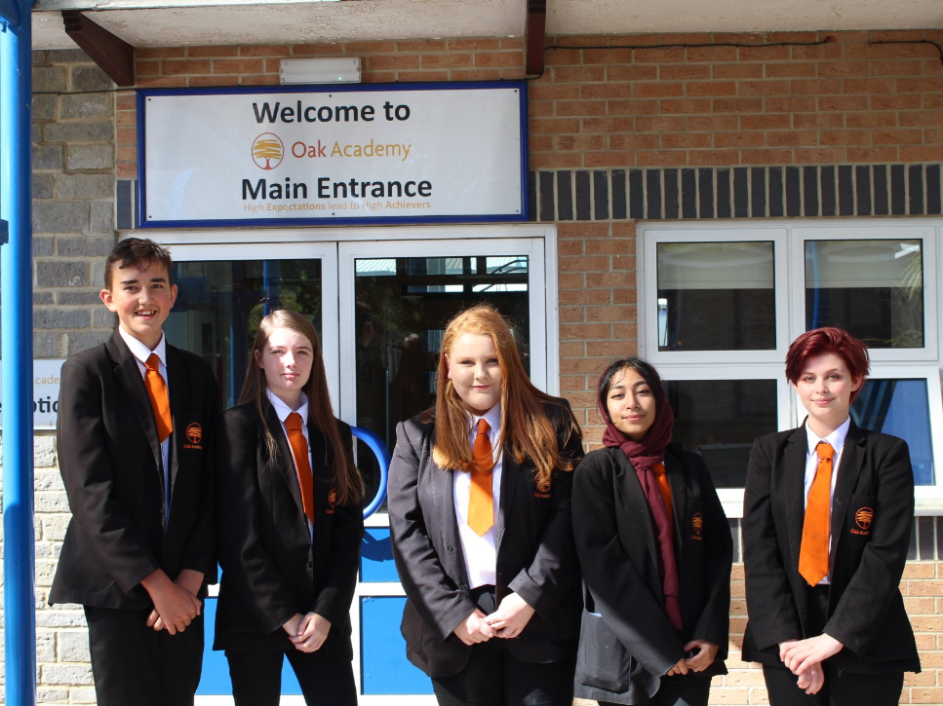

**SENIOR STUDENT TEAM AND STUDENT COUNCIL**

The role of the Senior Student Team and the School Council is to

work with Senior Leaders to focus on our Academy improvement

priorities. They are at the forefront of moving us forward from a

student perspective. The whole team contributes to Academy life in

a wide range of ways and students take part in a wide range of

opportunities locally, nationally and internationally.

**SOCIAL MEDIA**

The Academy uses Twitter as a social media platform to keep the community up to date with our recent news and activities; you can follow us using the following: @Oak_Academy. We also have a Facebook page, which can be found using: @OakAcademyAAT. Photo/videos will only be shared if Parent/Carers have given their consent to do so.

**UNIFORM**

We are proud of our Oak Academy uniform and the smart way in which our students present themselves. Uniform can be ordered through the Oak Academy Brigade online shop at:

<http://www.brigade.uk.com/>

Parent/Carers can log onto the Brigade website and purchase the uniform then make payment either through PayPal or Sage Page using credit or debit cards. Uniform will then be delivered free of charge to a home address at no extra cost. Please see the Academy website for further details.

Below is a brief reminder about uniform expectations. If at any time your child is unable to wear full uniform, please inform us of the reasons in writing. Students may be isolated if they choose to wear uniform inappropriately.

Compulsory:

**Blazer:** A black blazer with the Oak Academy logo purchased only through Brigade.

**Trousers / Skirt:** Black trousers which need to be tailored (no leggings or tight fitting trousers or any visible zips, buckles, buttons or belts). Girls are recommended to wear trousers. If they wish to wear a skirt, this should be a pleated knee length school skirt and not tight fitting.

**Shirt / Blouse:** A white school shirt which buttons to the neck for both boys and girls. T-shirts are not to be worn under school shirts or blouses.

**Tie:**  ALL pupils are required to wear an Oak Academy tie purchased only through Brigade.

**Footwear:** Plain sensible business like black school shoes (no trainers, Ugg boots or backless shoes). Any student arriving at Oak Academy in inappropriate footwear will be expected to borrow black plimsolls for the day.



**Socks:** Plain black, grey or white socks only.

**Hair:** Extreme hair-cuts (i.e. below Grade 2) / tramlines, coloured hair using unnatural hair colours or blocked two tone hair colours are NOT permitted.

**Jewellery:** The only jewellery to be worn is a watch, one signet ring and a pair of small stud earrings. Facial or tongue piercings are NOT permitted. No brightly coloured nail varnish, acrylic nail art or nails of a length where health and safety becomes an issue.

**Headwear:** Hats, hoods and scarves must not be worn anywhere on the premises.

**Ethnic Considerations, Symbols and Clothing:**  Appropriate consideration is given where feasible and desired for pupils with special dress or religious observance requirements or needs because of religious or cultural background. The wearing of a headscarf or hijab for religious reasons, is permitted. These should be short and in keeping with our school uniform, therefore black or navy with no designs, logos or sequins.

****Garments covering the face or whole body, e.g. the abaya and niqab, are not permitted.

**UNIFORM - PE Kit:**

* Polo shirt with Oak Academy logo purchased from Brigade.
* Black jumper
* Black jogging bottoms or girls can wear black leggings
* Black shorts or skirts
* Trainers

If you require clarification about any of these please speak to the School Office.

We would expect, for example, that ear-piercing would only take place at the beginning of the Summer holidays, so that earrings can be removed for PE and Dance when the Autumn Term begins.

If uniform is not correct students will be given the opportunity to correct it or may be isolated until the uniform can be corrected.

**WELFARE**

Students have the opportunity to receive support from qualified staff in a quiet environment, where they will be free to speak about any issues they may be having in or out of school.

Information will be treated as confidential unless it involves a Safeguarding issue.

**Provisional Term Dates 2020-21**

The provisional term dates and INSET days for 2020-21 are given below. The Academy may amend these during the academic year. Changes will be communicated all changes to parents in advance.

|  |  |  |
| --- | --- | --- |
| **Autumn Term** | Thursday 3rd September 2020  to Friday 18th December 2020 | Half Term 26th October 2020 -  30th October 2020 |
| **Spring Term** | Tuesday 5th January 2021  to Thursday 1st April 2021 | Half Term 15th – 19th February 2021 |
| **Summer Term** | Monday 19th April 2021  to Friday 23rd July 2021 | Half Term  31st – 4th June 2021  Bank Holiday Monday, 3rd May 2021 |

**Provisional Inset Dates 2020-21**

**(Academy closed to students)**

|  |  |
| --- | --- |
| **Autumn Term** | Thursday 3rd September 2020  Friday 4th September 2020  Monday 2nd November 2020  Friday 4th December 2020 |
| **Spring Term** | Monday 4th January 2021 |
| **Summer Term** | Friday 2nd July 2021 |