Year 11
Home Learning activities
While your child is at home please encourage them to spend time each day completing the work below.
All staff have placed resources in our Year 11 work area and/or on Microsoft Teams which students regularly access. To access our students are please following guidance below;
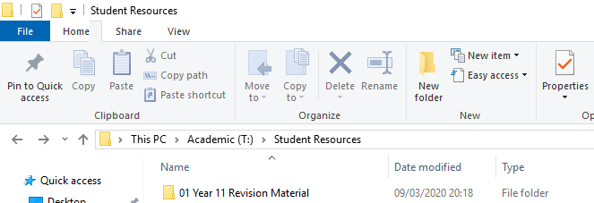
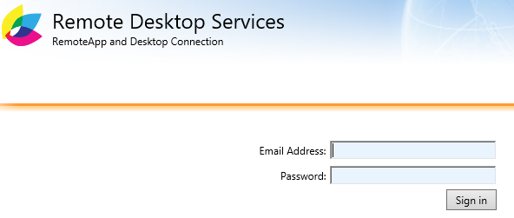
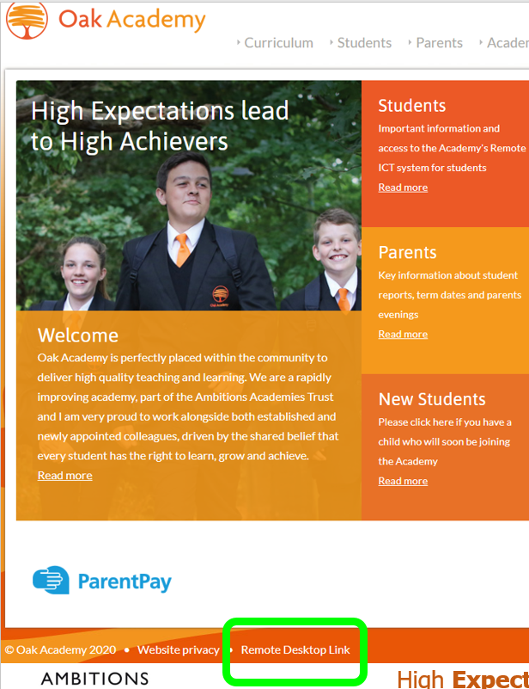
The following platforms can be used and may be referenced by teachers below;
Online Platform | Website | Username
Hegarty Maths | https://hegartymaths.com | Students create own logins
GCSE POD | https://www.gcsepod.com/gcse-learning-and-revision-pods/
Seneca Learning | https://app.senecalearning.com/courses | Students create own logins. See below
The Everlearner | https://www.theeverlearner.com/ | Student Emails

Core subjects – to be complete by all
Subject | Work to complete
English Language | Work through resources either on Teams or in Student Shared Area. All language practise papers to be completed.
English Literature | Work through resources either on Teams or in Student Shared Area. Literature revision materials in your orange "goody bags" to be used to help complete 5 practise Literature questions.
Maths | 1. Complete set work on Hegarty maths.  2. Work through Revisions guides and work books.  3. Complete papers that will be made available in the shared area.
Science | - Logon to The EverLearner and begin working through paper 1 in Biology, Chemistry and Physics. Balance your time equally between all three.  For all lessons ensure you watch videos, practise knowledge recall, test yourself and complete checkpoints.  - Access exam questions in the student shared area, on Microsoft Teams and at the following links;  https://www.savemyexams.co.uk/gcse-combined-science-trilogy-biology-aqa-new/  https://www.savemyexams.co.uk/gcse-combined-science-trilogy-chemistry-aqa-new/  https://www.savemyexams.co.uk/gcse-combined-science-trilogy-physics-aqa-new/
Physical Education | Complete the following HIIT session twice per week. https://www.youtube.com/watch?v=q20pLhdoEoY  If you struggle to access the link complete the following exercises for 30 secs each with a 10 second rest. Repeat four times for one full workout; 1) Burpees, 2) Squats, 3) Running on the spot, 4) Sit Ups

Options subjects – complete only where relevant
Subject | Work to complete
Art | Complete drawings, using materials provided, as instructed by Mrs Whitby.
Food and Nutrition | For those students resitting in June complete revision work in the students shared area ready for exam in June.
Computer Science | - Lesson Update and resources on MS Teams  - Revision materials and assessment information on Edmodo on course code - y8vaxr  - Seneca Revision on Fundamentals of Algorithms/Programming/Networks and Computer Systems class code 7cesge39um
ICT | - Revision resources and assessment learning outcomes on Edmodo using code - jx5x35.  - Exam resit information on student shared drive with materials and mark schemes.  - MS Team for communication and additional support.
Drama | - Use the revision booklets to go over comp 1 and follow the tasks and complete. use the printed knowledge organisers to develop your understanding of each section and revise.  - For further revision visit the BBC bitesize website and revise the AQA GCSE Drama section and also do some practise questions to test your knowledge https://www.bbc.co.uk/bitesize/examspecs/zrnjwty
French | - Revision resources across all skills and themes in the Y11 folder on the student shared area, including a list of revision websites and log-on details.  - Seneca Learning  11EB join the class by using the code joylxax0sw  11X join the class by using the code bxcuv1ug32
Geography | - All revision resources available in Student Shared area and via Teams  - Use Seneca Learning
History | - All revision resources available in Student Shared area and via Teams  - Use GCSE POD
Music | - Using the printed resource pack revise each section and do the practise speaking and listening exams.  - Go to BBC Bitesize and revise the GCSE EDUQAS Music topics and complete quizzes https://www.bbc.co.uk/bitesize/examspecs/zbmct39
Spanish | - Revision resources across all skills and themes in the Y11 folder on the student shared area, including a list of revision websites and log-on details.  - Seneca Learning: Join the class (Y11 Spanish) by using the code eh6dmgbw2e
Sport Studies | - Continue to work on coursework using personalised checklists. Email staff through attaching thw rok if possible to get it marked and returned.  - For those retaking the exam, continue to work through The Everlearner.
Sociology | - Revision resources in folder.  - Seneca Learning: Join the class (Y11 Sociology) by using the code 3o9tn0cv5p . Complete all sections
Media Studies | Using the resources in Microsoft Teams to help you, complete the tasks set in the folder entitled Revision Task Table.

If you have any questions during this time please do not hesitate to contact class teachers and myself at hrichley@leaf.bournemouth.sch.uk.

Yours sincerely

Mrs H Richley
Vice Principal

